Thoughts on DIY Electric Bicycles
Bill Cable Cornish NH
billxcable@gmail.com
May 2018

Riding a bicycle on fairly level terrain in nice weather on safe roads is one of the most pleasant and efficient way to travel. We experience lots of fresh air, earthy smells, and sounds of nature while getting healthy exercise. But when we live in a very hilly place like the Upper Valley sometimes the challenge of those hills is a bit more than we want to take on as a daily routine. An electric bicycle can easily solve the hill problem. The gradual evolution of electric bicycle motors and lithium ion batteries has made hills a non-issue. We travel a little slower up the hills, but the effort is about the same as we exert on level ground. That only leaves the weather and finding safe routes to deal with. On nice days commuting 20 or 30 miles can easily be done by most anyone.

The purpose of this handout is to give a brief overview of the technology available for those who may be thinking about getting an electric bicycle. The focus will be on the DIY (Do It Yourself) approach. Meaning you buy the components in pieces or as a kit and install them on your own bicycle. But the information should also be useful to someone who buys an off the shelf bicycle as well. It is the kind of information I would like to have had when I started exploring electric bicycles.

The information here is based on my experiences and research and inclinations so should not be considered the last word by any means. And this handout only provides you with some details, so you can do your own research before you make your own choices. I take no responsibility for any suppliers or equipment mentioned. DIY means you make the choices and accept the responsibility for your choices. You likely will save a significant amount of money for the same quality compared to buying a production electric bicycle. You will be able to fix issues yourself and you can switch the components to another bicycle if you wish. But you also take a gamble and have to deal with unexpected issues of your unique situation.

If you are not a DIY person just read through the information and use what you can to explore what production bicycles are out there. There are really nice expensive electric bicycles for those who can afford them. Pretty much plug and play. Local bicycle shops that sell electric bicycles are the safest choice as they can provide in person support for what they sell. We like to support local businesses. We understand that to maintain quality support they have to charge for what they do. Buying from a well established national online bicycle business is probably the next safest way to buy a complete bike. Also consider a used bicycle off Craigslist. You will get to see and ride the bike before you buy. And then a cheaper and chancier approach would be to buy a complete bike off Amazon or Craigslist or other online sources. Some sound pretty good at a very good price. Even close to the price of a DIY project. But spend some time doing the research before you buy. The descriptions are often misleading or skimpy. If the price is too good to be true it probably is.

Sources for information on electric bicycles

1. endless-sphere.com/forums/

From my experience this is the place to go to find out anything about electric bicycles and lithium batteries for bicycles. It has been active for many years and has an effective search feature. Any component or electric bicycle you are interested in is likely to be discussed. Like any online forum you need to understand that this is a diverse group with lots of opinions.

2. ebay.com

Ebay is a great place to learn about electric bicycles and components and get a ballpark price on something. Whether you buy or just do research ebay has a good search feature and it is worth looking here anytime you are going to buy something. You have to word your searches carefully sometimes to get what you want. I have always had good luck buying things from China but sometimes shipping takes weeks unless by air.

3. amazon.com

Amazon is another great place to learn about electric bicycles and components and get a ballpark price on something. One very useful feature is is customer reviews and answered questions. For a popular item that has lots of reviews you can learn a great deal by taking the time to read through them. Also the fast shipping if you are a Prime member is very nice along with the easy return policy. Note that not all products are from Amazon and some Chinese items have very slow shipping.

4. youtube.com

Wow! Am I thankful to all the people who take the time to post how-to videos on youtube. Often Chinese products come with no instructions or terrible instructions and you can find a youtube video that will take you through all the steps. Most popular electric bikes and components will have one or more youtube videos to help you. Definitely worth spending lots of time here learning about electric bicycles.

5. Various online sellers. I will list only a few here. Some I have dealt with and some I have not. There are plenty more out there.
a. goldenmotor.com
I have ordered from them before and they have been in business a long time.
They have a very good forum. Good place to check pricing. They have a USA
and Canadian distributor.
b. dillengerelectricbikes.com
c. Explore on your own there are too many to list

6. Area bike shops that sell electric bikes where you can try them
a. Claremont Cycle Depot Claremont
b. Omer and Bob’s Lebanon
c. http://www.ebikesofne.com Nashua
d. Many others between here and Boston

Why DIY?

Here are my favorite reasons for building a DIY electric bicycle

1. You can save about half the cost or better for the same quality

2. You can choose the bicycle to use and even move to another bike

3. A production electric bicycle is all proprietary so only one source

4. You can easily upgrade components like a larger battery

5. You know how everything works and how to troubleshoot and fix

Choosing a Lithium Battery

The lithium battery costs as much or more than the motor. You want to choose it carefully. Some bikes are still sold with lead acid batteries. They are cheaper but heavy and wear out quickly so cost more in the long run. Lithium batteries are good for 500 to 1000 charges before significant degrading. If you can travel 20 miles on a charge that is at least 10,000 miles for 500 charges. It will likely take years to put on that many miles and the batteries do last many years.

Be aware that lithium batteries store a lot of energy and damaging them or overcharging them can be dangerous. Your cell phone and computers use them so they are common to your environment. But bicycle batteries are larger and so I always advise charging them in a place where there is no danger of fire if they were to explode, just in case. I’ve never had that happen but you can see lots of examples on youtube. Also the batteries have a low voltage cut off. If discharged below that level then the battery can be ruined. The bicycle batteries you buy should also contain a BMS (Battery Management System) which will protect the battery from being overcharged or undercharged or having too much current drawn from it. That is a key safety system that you should make sure is built into your battery.

1. Types of lithium cells used in bicycle batteries

Lithium cells are hooked in series and parallel to make batteries
a. Lithium Iron Phosphate (LiFePO4) Each cell of this type charges to 3.6 volts
and they are a little safer than the others. Not as much energy per weight as
others so not as common in bicycles any longer. It is very important they
have a charger specific to the voltage they are to be charged to. The nominal
voltage is 3.2V which is the average voltage to use for calculations. The
safe low voltage cut off is about 2.5V.
b. Li-ion or Lipo (lithium polymer) Each cell of this type charges to 4.2 volts.
They have high energy per weight and are the most popular used in bicycles
at this time. Usually they are in cells about the size of AA batteries called
18650 (18mm in diameter and 65mm long). There is great variation in how much
energy can be stored in an 18650 cell and how much current it can supply. It
is very important they have a charger specific to the voltage they are to be
charged to. The nominal (average) voltage is 3.6V. The safe low voltage cut
off is about 3.0V.

2. Capacities of Bicycle Batteries

Lithium batteries are connected in series to increase the battery voltage and in parallel to increase the battery current. A combination of both is used. You might see a battery referred to as 13S5P. Which means 13 in series of 5 cells in parallel or 65 cells. If these were li-ion cells the nominal voltage would be 13 x 3.6 = 46.8V. Historically bicycles have used 24V and 36V and 48V. Some riders go to even higher voltage but currently 36V and 48V are the common options. Is 36V or 48V best? Both work fine but the battery has to match the motor and controller voltage and also match the motors peak demand for current.
Important specifications for a battery

a. Voltage – So this will be either 36V or 48V. Close is good enough.
For lithium iron batteries
3.2V x 12 = 38.4V so 12 in series for 36V
3.2V x 16 = 51.2V so 16 in series for 48V
For li-ion batteries
3.6V x 10 = 36V so 10 in series for 36V
3.6 x 13 = 46.8V so 13 in series for 48V
The voltage can be thought as the pressure through the wire so a 48V battery
would have a bit more pressure than a 36V battery

b. Amperage or current – This can be thought of as the flow in the wire. It
generates heat if the wire is too small. Generally most motors will need at
least 15A when working hard and some motors can demand much more so the
battery needs to match the motor or the motor will demand too much and the BMS
will shut the battery down temporarily to protect it. To meet higher demands
of current more cells are put in parallel. Things being equal a 36V battery
will require more current to do the same work as a 48V battery. You will
typically expect to drain amps in the range from 0A to 20A depending on how
hard you pedal and whether you are on a flat or hill.

c. Ampere hours (AH) – This is how many amps a battery can supply for an hour
before reaching its low voltage cut off. This is important and sellers usually
tell you the AH of a battery. Usually it is something like 8AH or 10AH or 12AH
or 15AH or 20AH. The larger the AH the more range but also the more weight.
How much current you drain from the battery greatly affects how many AH you
can actually get out of it. A steady drain of 15A may only get 10AH out of a
15AH battery whereas a steady drain of 5A may get the full 15AH. Demanding a
lot of current will greatly reduce the useful energy your battery can supply.

d. Watts or KiloWatts (W or KW) – A kilowatt is 1000 watts. This is measure of
power where W = V x A or KW = (V x A)/1000. A power unit we are more familiar
with is horse power (HP) where 1 KW = 1.34 HP

e. Watt Hours or Kilowatt hour (WH or KWH) – This is a measure of energy and is a
great way to estimate the energy in a battery. As mentioned if you take the
energy out slowly you will get a lot more out of a battery than taking it out
fast. So going slower and demanding less of your bicycle battery will get you
a lot farther than going full speed.
For a 36V 10AH battery 36V x 10AH = 360 WH or .360 KWH
For a 48V 10AH battery 48V x 10AH = 480 WH or .480 KWH
So a 48V 10AH battery has about a third more energy than a 36V 10AH battery or
you would need a 36V 13.3AH battery to have the same energy. From my
experience I would say you would get somewhere from 10 to 20 miles from a 48V
10AH battery doing some pedaling on mixed terrain.

3. Styles of Bicycle Batteries
You want to be able to fit the battery to the bicycle in a convenient way. So its shape it important. The battery is a bit heavy so having it lower on the bike makes it more stable. Lots of styles are available. A hard case is nice.

4. Costs of Bicycle Batteries
If you know the battery is made with quality Samsung or Panasonic 18650 cells that is a big plus but often you don’t know. On ebay you can get 36V 10AH battery recommended for a 350W motor with BMS and charger and shipping for about $200. A similar 48V battery is around $250. Remember to pick your motor first and size the battery to the motor. I prefer at least a 12AH battery which is more costly. Make sure the battery has a BMS and charger. You will likely have to make a connector to connect to your motor wires.

Motor Controller

The motor is connected to the battery via a controller which usually has a throttle connected to it. The controller must match the voltage of the battery and the needs of the motor. Unless you are experimenting, you would usually buy the controller from the same place you buy the motor and is matched specifically to it. Sometimes the motor unit will have a controller built in, so you do not have to buy an external controller. There can be lots of connections to make especially with external controllers. It can seem daunting if no instructions, but you are likely to fine sources with hints on youtube and elsewhere. It usually works out okay with a little head scratching. Just don’t get the battery polarity wrong. The red for positive and black for negative usually works but make sure.

Choosing A Bicycle Motor

Brushless (and Gearless) Front Hub Motor
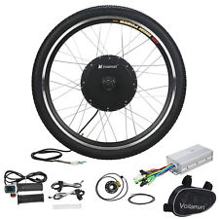
This type of bicycle motor replaces your front wheel
If just the hub is supplied, you will need to spoke a
rim to the hub. It is direct drive. Charge controller may be separate or inside the hub.

Advantages
1. Can be lower cost
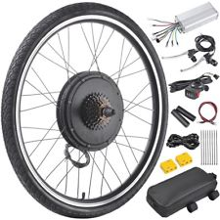
2. Easy installation
3. Can offer regenerative charging/braking
4. Can be high speed
5. Bike gearing not affected

Disadvantages
1. Heavy
2. Cogging resistance when power is off
3. If high powered requires powerful battery
4. Front axle needs torque arm to keep from spinning

Brushless (and Gearless) Rear Hub Motor

This type of motor replaces your rear wheel
If just the hub is supplied, you will need to spoke
a rim to the hub. It is direct drive. Charge controller may separate or inside the hub.

Advantages
1. Can be lower cost
2. Easy installation
3. Can offer regenerative charging/braking
4. Can be high speed
5. Lots of choices available

Disadvantages
1. Heavy
2. Cogging resistance when off
3. If high powered requires powerful battery
4. Need to fiddle with rear gearing

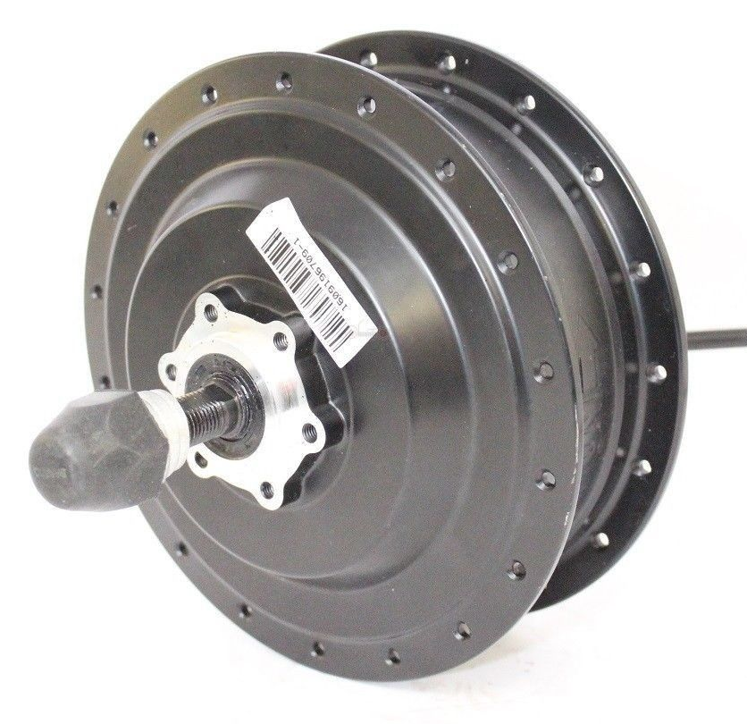
Geared Front Hub Motor

This type of motor replaces your front wheel. If only the hub is supplied, you will need to spoke a rim to
the hub. Internally there is a planetary gear system
which gears down the motor for more torque but less speed.

Advantages
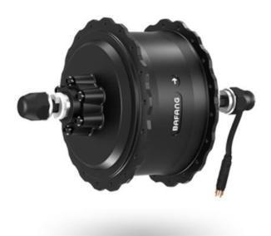
1. Medium cost
2. Easy installation
3. Freewheels easily when power is off
4. More efficient than gearless hub motor
5. Light weight
6. Good torque for hills
7. Not as demanding on battery

Disadvantages
1. Slower speeds than gearless hub motor
2. No regenerative charging/braking
3. Front axle needs torque arm to keep from spinning

Geared Rear Hub Motor

This type of motor replaces your rear wheel. If only
the hub is supplied you will need to spoke a rim to
the hub. Internally there is a planetary gear system
which gears down the motor for higher torque and
less speed.

Advantages
1. Medium cost
2. Easy installation
3. Freewheels easily when power is off
4. More efficient than gearless hub motor
5. Light weight
6. Good torque on hills
7. Not as demanding on battery

Disadvantages
1. Slower speeds than gearless hub motor
2. No regenerative charging/braking
3. Need to fiddle with rear gearing

Mid Drive Motor

For DIY projects they are primarily made by two companies

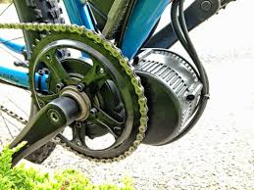
1. Bafang/8Fun BBS02 - This mid drive motor comes in
36V and 48V versions and in various power (watts) versions. Controller built in. Fits 68-73 bottom brackets

Advantages
1. High quality
2. Mounts low on the bike
3. More efficient than gearless hub motor
4. Free wheels easily when power is off
5. Good torque as it is geared down
6. Quiet

Disadvantages
1. Pricey at $400 or more
2. Must replace bottom bracket with the unit
3. Only single front gear
4. Slower than gearless hub motor

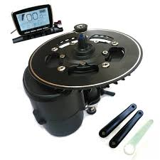
2. Tongsheng TSDZ2 – This mid drive motor comes in 36V and 48V versions and various power (watts) versions. Controller is built in. Fits 68-73mm bottom brackets
Advantages
1. High quality
2. Mounts low on the bike
3. More efficient than gearless hub motor
4. Free wheels easily when power is off
5. Quiet
6. Good torque as it is geared down
7. Torque sensing assist feels natural and no throttle is needed

Disadvantages
1. Pricey at $400 or more
2. Must replace bottom bracket with the unit
3. Only a single front gear
4. Slower than gearless hub motor

I hope this information provides helpful hints in choosing or building an electric bicycle. Feel free to contact me with suggestions or corrections. Happy pedaling. ~Bill Cable Cornish, NH May 17, 2018

